Bam works to improve the general welfare of working Donkeys in Eastern Uganda; firstly, through training of Donkey's owners how to use easy to make Saddles from sisal sacks, to prevent injuries behind their tails and the backs, we also train in humane handling and care, treatment and feeding. We make routine visits and have organized clinics where several
injured Donkeys get treated free of payments. @Animal-kind international supports this good initiative Please support us to help the less privileged Donkeys in Uganda.
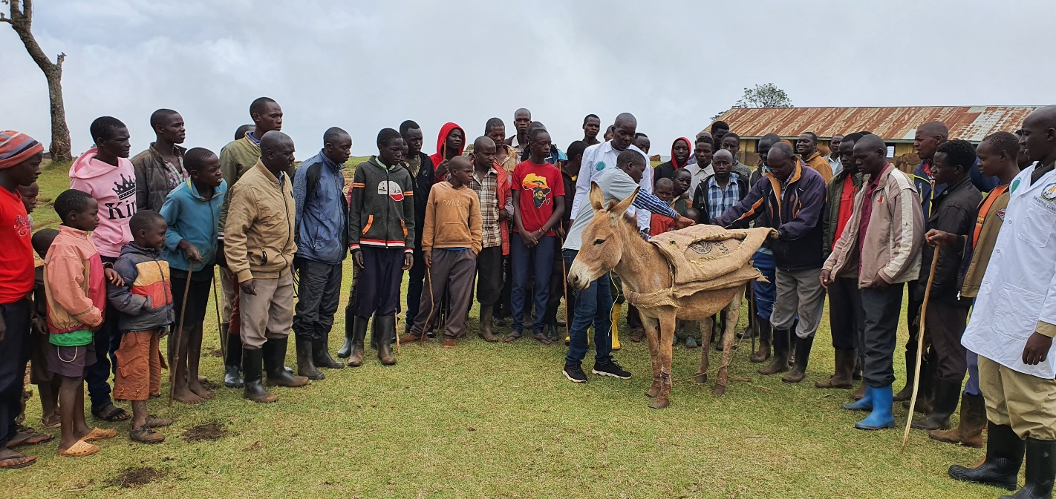

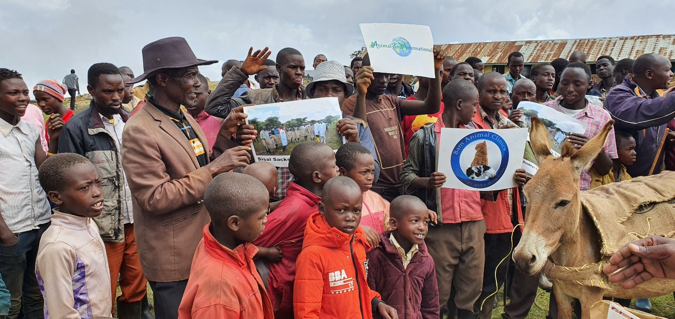
Bam continues to support donkey owners in Eastern Uganda even with a lot of constraints and only supported by single partner, the Animal-kind International.

Restraining a Donkey for especially treatment and or for any health management purposes is one of the hardest activity as donkeys tend to be so strong and quite often can kick harder, so most often, the donkey is held on the ground with a ropes and supported as well to enable ease of work. Sometimes this is misinterpreted as torture but in the field situation, and sometimes with excitation resulting from the presence of other donkeys, the donkeys will change their characters towards resisting directives as opposed to when they were at homes. In the picture below, because of inadequate restraining facilities, owners have to restrain using ropes to have their animals treated of various ailments.
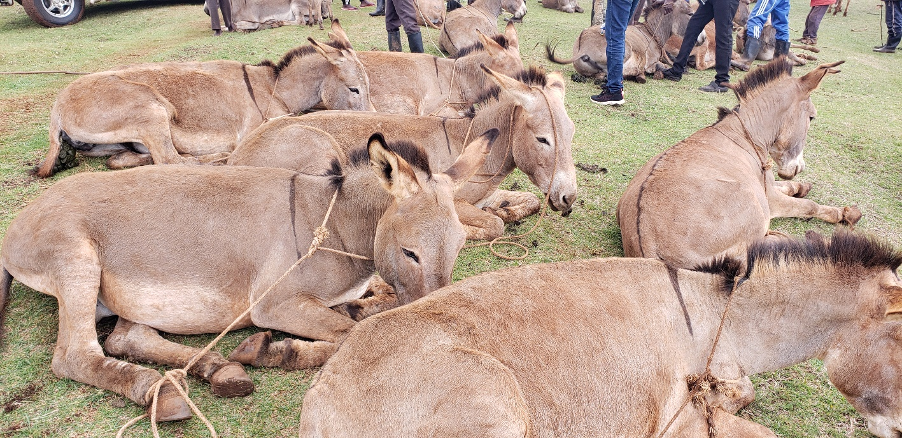

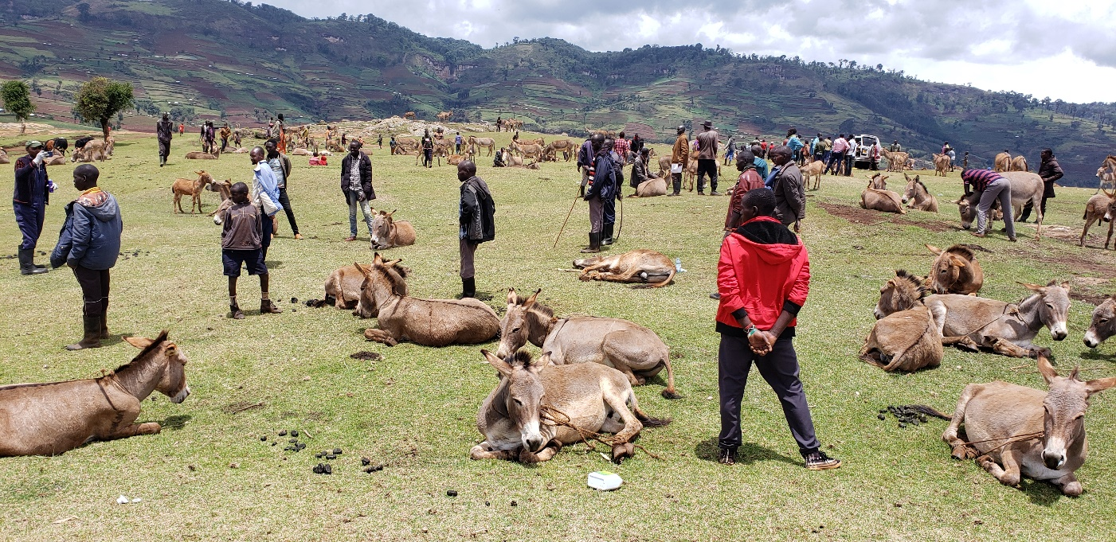
An overwhelming turns up for Veterinary care! Donkey owners in Kitawoi sub county Kween District upon hearing about our donkey welfare services, many locals turned up with their Donkeys at our treatment and welfare training site. They will then receive our welfare package including; the new saddle design from sisal sacks training, free diagnosis and treatments.

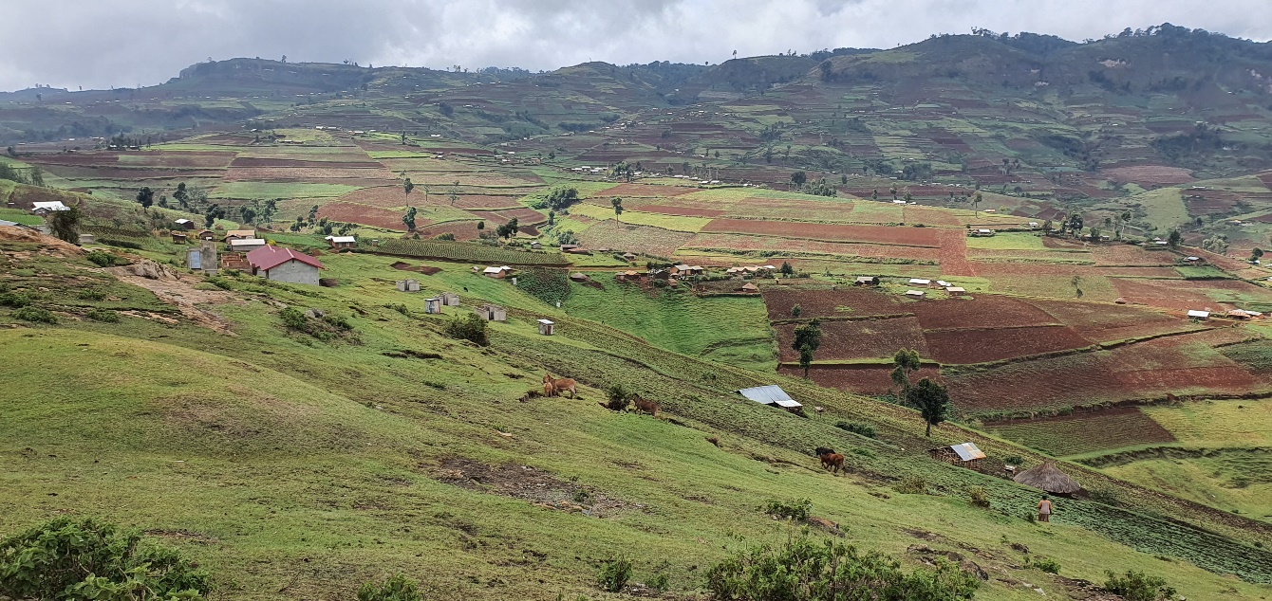
The nature of terrains in the Sebei region is the reason donkeys are used as transport means. Besides the soils are sticky for any motorists. Donkeys are also used for ploughing almost in all gardens as seen 90% work is done by donkeys. There is therefore need to ensure good welfare for the donkeys in this Sebei region.

Most food produced here is organic vegetables as the soils are still very fertile and with minimal pastes challenges. The region is the food basket for Uganda and the neighboring countries like Kenya and Sudan.
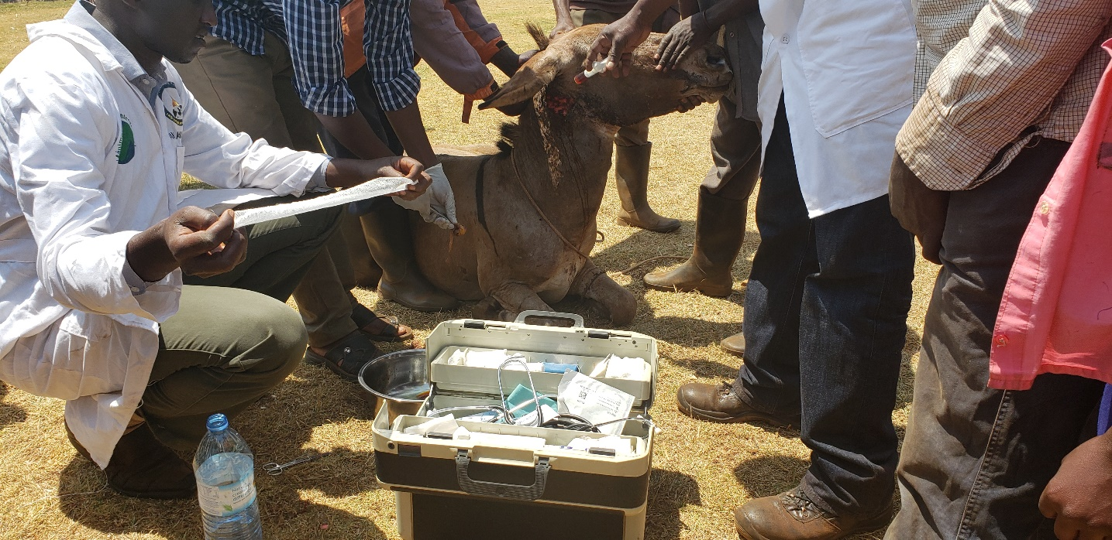
Donkey fighting is common and is a major cause of wounds on top of poor saddle and cruelty matted to them by their would be masters. Poor nutrition and long working hours are other causes of suffering and poor health conditions. More effort needed to train locals about the good welfare practices but we can only do this according to our reach.

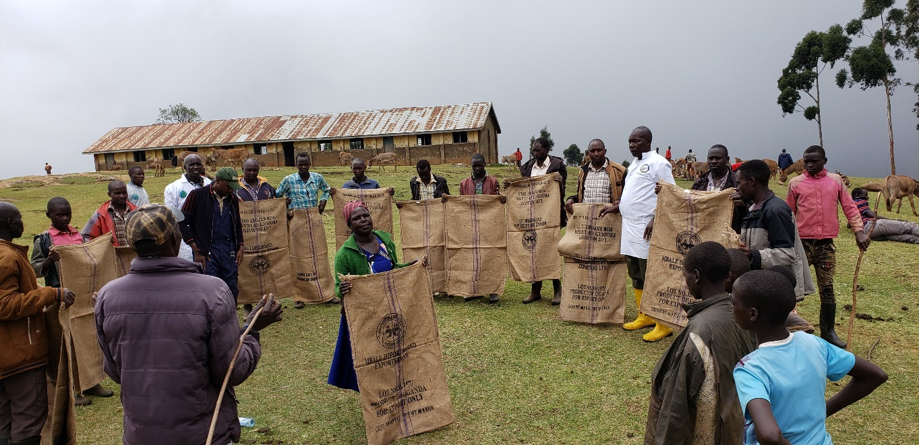
In Kitawoi subcounty, Kween District, our staff training donkey owners about humane donkey management with emphasis to the; Use of sisal sacks saddles which provide enough protection for working donkeys. The easy to make and durable sisal sack saddle is very effective at cushioning the back of the donkey as well as the base of the tail from abrasion or cut wounds when donkeys are used to carry luggage.

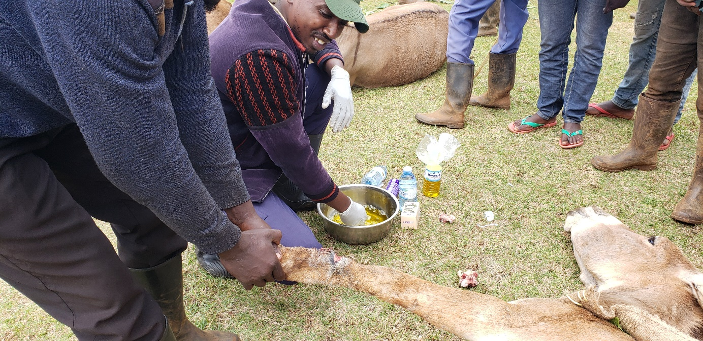
Some of the many Donkeys welfare concerns that necessitated our intervention to help support the relief from the suffering includes; Over working of Donkeys, over loading, bad types of saddles used that do not offer basic protection from injuries, poor nutrition, poor health when animals stay with both ecto and endo parasites for almost the rest of her life. Most affected are the working donkeys because they bear the heavy loads on top of their poor health.

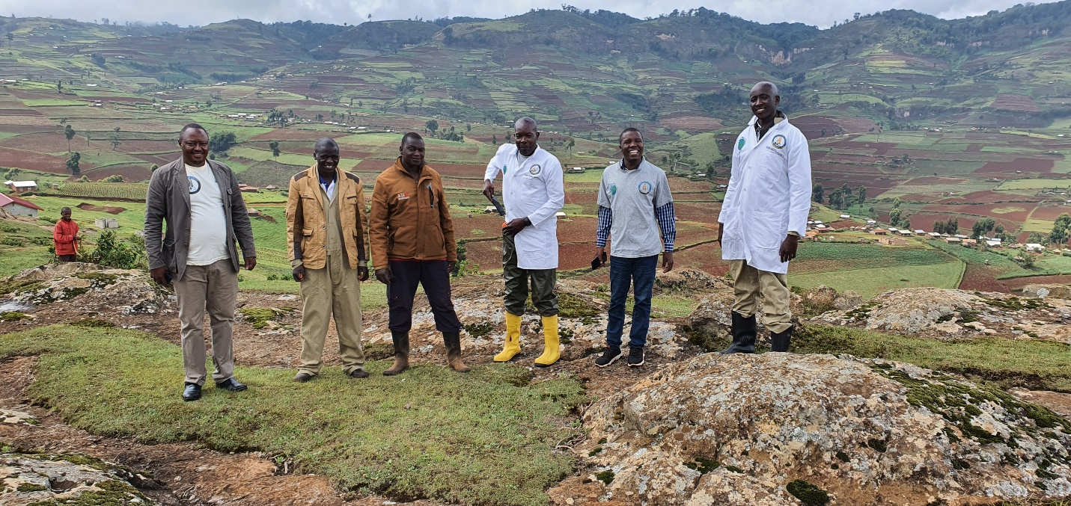
Team reaching out to very high altitudes in a bid to access the Donkeys there. This is Kween District where we have many Donkeys and with lots of challenges concerning their welfare.

In general, our work is mainly:
- to ensure the communities understand the importance of treating their Donkeys,
- People are advised on work limits and maximum load a donkey can carry at a time,
- People are advised on how to construct simple shelters or houses for their donkeys,
- Community policing is emphasized to minimize theft of donkeys as well as construction of fences around to keep the donkeys especially at night.
- The case of poor harnesses, Bam together with Animal kind international introduced easy to make and use saddles that provide ample cushion on the Donkey while currying any loads.
The sisal made saddles prevent damages at the back of the tails and on the back of the Donkey. We also curry out routine clinics to help diagnose and treat their animals free of charges, handling surgical cases as well. This helps them to understand the importance of treatment as most of our treated animals get cured of their illnesses.
More Pictures:

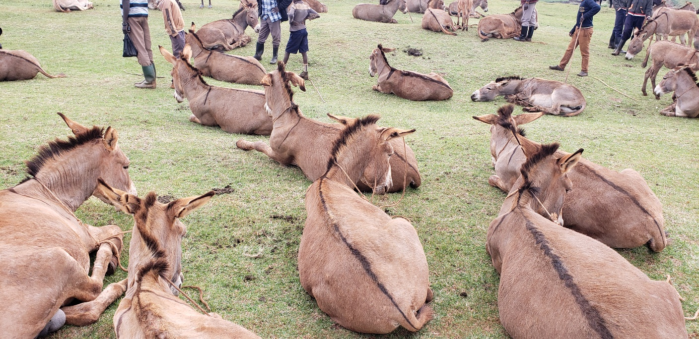
c

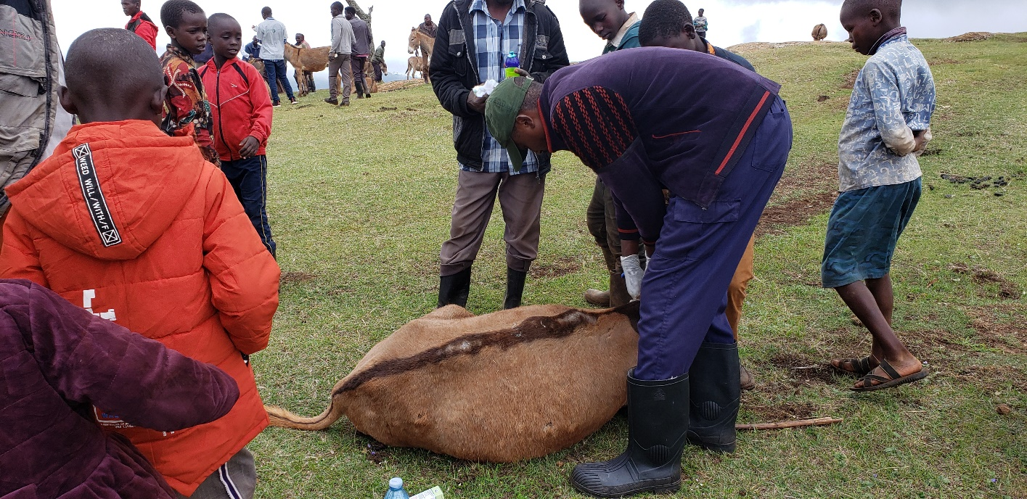
Donkeys prepared for mass treatment esp. to control endo and ecto parasites and those found with wounds are also managed accordingly.

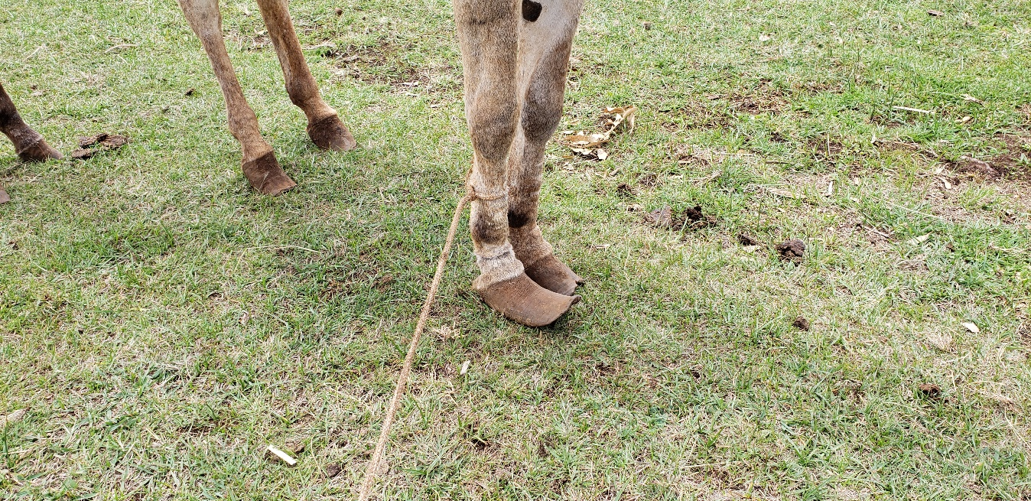
A case of overloading and use of poor saddles leading to vertebral displacement, with lots of fluids accumulation, the effect is fatal!

